

NeuroSense AI: A Self-Learning Emotion-Aware Robotic Intelligence System

A INTERNSHIP PROJECT REPORT

Submitted by

ARUL GNANAKUMAR (95072317016)

in partial fulfillment for the award of the degree of

BACHELOR OF TECHNOLOGY

in
ARTIFICIAL INTELLIGENCE AND DATA SCIENCE

FRANCIS XAVIER ENGINEERING COLLEGE
(Autonomous)
TIRUNELVELI-627003

ABSTRACT

Modern machines are powerful, but they do not truly understand human emotions or physical condition. In industries and healthcare environments, many accidents and health issues occur because machines cannot detect human stress, fatigue, or discomfort early. Most existing systems react only after a problem happens. There is a strong need for intelligent systems that can understand human condition and act before danger occurs.

NeuroSense AI is a human-centered robotic intelligence system designed to bridge the gap between humans and machines. The system combines simple body sensors, artificial intelligence, and a robotic response mechanism to create a smart and caring assistant. It monitors basic human signals such as body temperature and heart pulse to understand the user’s condition. Instead of only displaying data, the system analyzes patterns and predicts stress levels using self-learning AI.

The core innovation of this project is its ability to learn from experience. NeuroSense AI stores past data in a compact memory format and improves its decision-making over time. When it detects rising stress or abnormal conditions, the system automatically takes preventive actions such as activating cooling systems, providing alerts, or adjusting robotic responses. It also supports feedback-based learning, allowing the AI to become smarter with continuous use.

This project demonstrates how robotics can evolve from simple automation into emotionally aware and predictive systems. Unlike traditional robots that only follow commands, NeuroSense AI focuses on understanding human well-being and safety. The system includes both hardware components, such as sensors and microcontrollers, and software modules, including AI prediction, data simulation, and a monitoring dashboard.
NeuroSense AI has strong potential applications in industrial worker safety, hospitals, elderly care, and assistive robotics. It offers a low-cost prototype model that can be scaled into advanced real-world solutions. By combining emotion awareness, predictive intelligence, and adaptive robotics, this project lays the foundation for future human-centric AI systems that not only perform tasks but also support and protect human life.
CHAPTER- 1
INTRODUCTION

1.1 PROJECT OVERVIEW
Technology is growing rapidly, and machines are becoming smarter every day. However, most machines and robots still lack one important ability — understanding humans. They can perform tasks quickly and accurately, but they do not recognize human stress, discomfort, or emotional state. In real-world environments such as industries, hospitals, and elderly care, this limitation can lead to safety risks and delayed responses. Machines usually react only after a problem occurs instead of preventing it.

NeuroSense AI is designed to change this approach by introducing a more human-centered form of artificial intelligence. This project focuses on building an intelligent robotic system that can monitor basic human body signals and respond in a smart and supportive way. The goal is not just automation, but creating a machine that can sense human condition and act as a helpful companion.
The system works by combining simple sensors, intelligent software, and robotic components into one integrated platform. It collects basic physiological data such as body temperature and heart pulse to understand the user's physical state. This information is then analyzed by an AI engine that identifies patterns and estimates stress levels. Instead of simply displaying readings, the system interprets the data and makes meaningful decisions.

One of the key ideas behind NeuroSense AI is predictive intelligence. Rather than waiting for dangerous situations to occur, the system attempts to detect early warning signs. When unusual patterns are detected, the system can trigger preventive responses such as alerts, cooling mechanisms, or adaptive robotic actions. This makes the system more proactive than traditional machines.
Another important feature of the project is self-learning capability. The AI continuously improves by remembering past data and learning from feedback. Over time, the system becomes more accurate and responsive to human needs. This adaptive nature allows the system to evolve from a basic prototype into a smarter and more personalized assistant.

Overall, NeuroSense AI represents a step toward the future of human-aware machines. It demonstrates how robotics and artificial intelligence can move beyond simple automation and become more empathetic and supportive. By focusing on safety, prediction, and learning, this project lays the foundation for intelligent systems that are not only efficient but also aware of human well-being.

1.2 CORE CHALLENGES ADDRESSED
In many real-world environments such as industries, hospitals, and assisted living spaces, machines and robots are designed mainly for automation and efficiency. While they perform tasks quickly, they often lack awareness of human condition. One of the biggest challenges is that machines cannot understand human stress, fatigue, or discomfort. This creates a gap between human needs and machine responses.
Another major issue is delayed reaction. Most existing systems respond only after a problem occurs. For example, a machine may detect overheating or health stress only when it becomes dangerous. This reactive approach increases the risk of accidents and reduces overall safety. There is a growing need for systems that can predict problems early instead of responding late.

A further challenge is the lack of adaptive intelligence. Traditional machines follow fixed instructions and cannot learn from experience. They behave the same way every time, regardless of changing conditions. This makes them less suitable for environments where human well-being is important. Additionally, many advanced AI systems are expensive and complex, making them difficult to implement in low-cost or small-scale settings.
NeuroSense AI addresses these challenges by focusing on human-centered intelligence. It aims to build a system that not only performs tasks but also understands and supports human condition in a simple and accessible way.

1.3 TECHNICAL OBJECTIVES
The primary objective of NeuroSense AI is to develop an intelligent robotic system that can sense, understand, and respond to human physical condition. The system is designed to monitor basic body signals such as temperature and heart pulse, which can indicate stress or discomfort. By analyzing these signals, the system aims to create a safer and more supportive interaction between humans and machines.
Another key objective is to introduce predictive capability. Instead of waiting for dangerous situations, the system aims to identify early warning signs and take preventive action. This helps transform machines from reactive tools into proactive assistants that can reduce risks and improve safety.
The project also focuses on building self-learning intelligence. The AI is designed to store past data and improve its performance over time. By learning from previous patterns and user feedback, the system becomes more accurate and adaptive. This makes the technology more practical and closer to real-world intelligent systems.

A further objective is to develop a low-cost and scalable prototype. The system uses simple hardware components and lightweight software models, making it affordable and easy to expand. This ensures that the concept can be applied in various domains such as worker safety, healthcare assistance, and intelligent robotics.
Overall, the technical vision of NeuroSense AI is to create a bridge between humans and intelligent machines. By combining sensing, prediction, and learning in a single platform, the project aims to demonstrate how future AI systems can become more aware, responsive, and supportive of human life.

1.4 SYSTEM ARCHITECTURE
The NeuroSense AI system is designed using a simple and easy-to-understand layered structure. The architecture combines sensing, intelligence, and action into one connected system. Each layer has a specific role, but all parts work together to create a human-aware robotic assistant.
The first layer is the sensing layer, which collects basic human body signals. Small sensors measure parameters such as heart pulse and body temperature. These signals help the system understand the physical condition of the user in real time. The data collected is simple but meaningful, as it provides early signs of stress or discomfort.

The second layer is the intelligence layer, which acts as the brain of the system. This layer uses artificial intelligence to analyze the incoming sensor data and identify patterns. Instead of only reading values, the AI interprets the data and estimates the user’s stress level. It also compares current readings with past data stored in memory, allowing the system to make smarter decisions over time.

The third layer is the control and response layer. Once the AI understands the situation, it decides how the system should react. Depending on the detected condition, the system can trigger alerts, activate cooling mechanisms, or adjust robotic movements. These responses are designed to provide early assistance and prevent potential risks.
The final layer is the learning and storage layer. The system stores important data in a compact format and uses it for continuous improvement. By remembering previous experiences and user feedback, NeuroSense AI becomes more accurate and adaptive. This self-learning ability allows the system to evolve from a simple prototype into a more intelligent and personalized assistant.

1.5 ANTICIPATED PROJECT OUTCOMES
The primary outcome of this project is a working prototype that demonstrates how machines can become more aware of human condition. The system will show that it is possible to combine simple hardware and intelligent software to create a predictive and responsive robotic assistant.
Another expected outcome is the demonstration of self-learning artificial intelligence in a practical environment. The project will highlight how AI can improve performance over time by learning from data and feedback. This makes the system more reliable compared to traditional static machines.

The project also aims to prove the concept of predictive safety. Instead of reacting after a problem occurs, the system will demonstrate early detection and preventive action. This approach can significantly improve safety in environments where human well-being is critical.
In addition, the project will provide a scalable foundation for future development. The prototype can be expanded into real-world applications such as industrial safety systems, hospital monitoring assistants, and smart rehabilitation devices. By combining emotion awareness, prediction, and adaptive robotics, NeuroSense AI opens the door to the next generation of human-centric intelligent systems.

CHAPTER - 2

PROBLEM STATEMENT

In today’s fast-moving world, machines and automation systems are widely used in industries, hospitals, and daily life. While these systems are efficient and powerful, they are mostly designed to perform tasks without understanding the human condition. Machines can measure performance and execute commands, but they do not recognize when a person is stressed, tired, overheated, or physically uncomfortable. This gap between human needs and machine awareness creates serious limitations in real-world environments.

In industrial workplaces, workers often operate in high-pressure conditions where fatigue and stress can build up quickly. Existing safety systems mainly depend on manual monitoring or simple alerts that activate only after a critical threshold is crossed. By the time a warning appears, the risk may already be high. Similarly, in healthcare and elderly care settings, many monitoring devices only display raw data without interpreting it in a meaningful way. This makes it difficult to take preventive action early.

Another major problem is that most current machines are reactive rather than predictive. They respond only when a problem becomes visible, instead of identifying early warning signs. Human stress and physical strain usually develop gradually, but traditional systems fail to track these subtle changes over time. As a result, potential risks such as health issues, reduced productivity, or accidents may go unnoticed until it is too late.

Additionally, most robotic systems are not designed to learn from experience. Once programmed, they continue to operate in the same way without adapting to user behavior or environmental changes. This lack of adaptability limits their usefulness in dynamic and human-centered environments. A system that cannot learn or evolve will always remain limited in its ability to support human well-being.
There is a clear need for a new generation of intelligent systems that can understand human conditions in a more natural and supportive way. Such a system should be able to monitor basic human signals, interpret them intelligently, and take preventive actions before problems escalate. It should also have the ability to learn continuously and improve its responses over time.

Addressing these challenges requires a shift from task-focused automation to human-aware intelligence. The goal is not just to build smarter machines, but to create systems that can sense, predict, and respond to human needs. This problem forms the foundation for the development of NeuroSense AI, which aims to bridge the gap between human well-being and intelligent machine assistance.

CHAPTER - 3

EXISTING SYSTEM

3.1 TRADITIONAL ROBOTIC SYSTEMS
In today’s industries and healthcare environments, robots and automated machines are widely used to improve speed and efficiency. These machines are designed to perform specific tasks such as lifting objects, assisting in surgeries, monitoring patients, or assembling products in factories. They are programmed to follow fixed instructions and respond to direct commands.

However, traditional robotic systems mainly focus on task completion rather than human condition. They operate based on predefined rules and do not adapt to human emotional or physical changes. For example, if a worker feels stressed or tired, the robot will continue operating in the same way because it does not recognize the human state. Similarly, in hospitals, machines may record vital signs, but they do not actively interpret stress patterns or predict discomfort.

This shows that current robotic systems are task-oriented rather than human-oriented.

3.2 REACTIVE MONITORING SYSTEMS
Many existing systems use sensors to monitor physical parameters such as temperature, heart rate, or environmental conditions. These systems are helpful because they provide real-time data. However, most of them only display information without intelligent analysis.

For example, if a worker’s heart rate increases, the system may show a higher value on a screen, but it does not automatically predict whether the increase is dangerous. It simply records and reports data. A human operator must interpret the readings and take action manually.

This approach is called reactive monitoring. It reacts after a change is observed but does not predict future risks. Because of this limitation, early warning signs may be ignored or delayed, increasing the chances of accidents or health issues.

3.3 LACK OF EMOTIONAL AWARENESS IN MACHINES
One major limitation of existing systems is the absence of emotional intelligence. Machines can measure numbers such as pulse rate or temperature, but they cannot understand what these values mean in a human context.
Human emotions like stress, anxiety, and fatigue often influence physical signals. When these signs are not recognized, machines may continue to operate in ways that increase discomfort or risk. For example, in industrial environments, high stress levels may reduce concentration and increase the probability of mistakes. However, traditional robotic systems do not adjust their behavior based on such conditions.

This gap between human emotional state and machine behavior reduces safety, efficiency, and trust in automated systems.

3.4 LIMITATIONS OF CURRENT AI-BASED SYSTEMS
Although some modern systems use Artificial Intelligence, many of them are still limited in scope. They may analyze data for specific purposes, but they often lack continuous learning and personalization. Once programmed, they follow fixed algorithms and do not improve significantly over time.

Most existing AI systems also depend heavily on cloud processing and internet connectivity. This can cause delays and reduce reliability in real-time environments such as factories or hospitals. In addition, they usually focus on performance optimization rather than human well-being.

Another limitation is the absence of integrated feedback mechanisms. Many systems do not learn from user responses or adapt based on experience. Without feedback-based learning, machines remain static rather than evolving intelligently.

SUMMARY OF EXISTING SYSTEM
In summary, current robotic and monitoring systems are efficient but limited. They are reactive instead of predictive, data-driven but not emotion-aware, and automated but not adaptive. These limitations highlight the need for a smarter, human-centered solution that can understand, predict, and respond to human conditions in real time.
CHAPTER - 4

PROPOSED SYSTEM

4.1 OVERVIEW OF THE PROPOSED SYSTEM
To overcome the limitations of existing systems, this project introduces a new approach called NeuroSense AI. The proposed system is a human-centered robotic intelligence platform designed to understand human physical condition and respond intelligently. Instead of only performing tasks, the system focuses on human safety, comfort, and well-being.
The main idea behind the proposed system is simple: collect human body signals, analyze them using intelligent software, and respond in a helpful way. The system combines sensors, artificial intelligence, and robotic components into a single integrated solution. This allows the machine to not only monitor but also understand and act.

Unlike traditional systems that only react after problems occur, this system aims to predict early warning signs and take preventive actions.

4.2 HUMAN SIGNAL MONITORING
The proposed system continuously monitors basic human physiological signals such as body temperature and heart pulse. These signals provide valuable insights into a person’s physical condition and stress levels. Instead of using complex medical devices, the system uses simple and low-cost sensors to make the solution affordable and scalable.
The collected data is processed in real time by a microcontroller, which acts as the local brain of the system. This ensures fast response without relying entirely on internet connectivity. By continuously monitoring these signals, the system creates a live understanding of the user’s condition.

This real-time awareness forms the foundation for intelligent decision-making.

4.3 AI-BASED PREDICTIVE INTELLIGENCE
One of the most important features of the proposed system is predictive intelligence. The system does not just display sensor values; it analyzes patterns and identifies abnormal trends. For example, a gradual increase in pulse rate combined with rising temperature may indicate stress or fatigue.
The artificial intelligence module studies these patterns and predicts potential risks before they become serious. This predictive capability transforms the system from a reactive tool into a proactive assistant. Instead of waiting for emergencies, it provides early warnings and preventive responses.

This approach improves safety and reduces the chances of sudden failures or health issues.

4.4 SELF-LEARNING AND FEEDBACK MECHANISM
Another key feature of the proposed system is its ability to learn over time. The system stores past data and uses it to improve future decisions. This process is known as self-learning. As more data is collected, the AI becomes better at identifying patterns and making accurate predictions.
The system also includes a feedback mechanism. Users can provide simple feedback about whether the system’s actions were helpful or not. This feedback allows the AI to adjust its behavior and become more personalized. Over time, the system evolves into a smarter and more adaptive assistant.

This learning capability makes the system dynamic rather than static.

4.5 INTELLIGENT ROBOTIC RESPONSE
The proposed system is not limited to monitoring and prediction. It also includes intelligent response mechanisms that convert insights into action. When the system detects high stress or abnormal conditions, it can automatically trigger supportive responses.
These responses may include activating cooling systems, generating alert sounds, displaying visual indicators, or adjusting robotic movements. The goal is to provide immediate assistance without requiring manual intervention. This creates a seamless interaction between humans and machines.
By combining sensing, prediction, learning, and action, the proposed system creates a complete intelligent loop. It moves beyond traditional automation and introduces a new generation of human-aware robotic systems that are safer, smarter, and more supportive.

4.6 SYSTEM ARCHITECTURE

The system architecture of NeuroSense AI represents how different components work together to create an intelligent and human-aware robotic system. The architecture is designed in a simple and modular way so that each part has a clear role. The system mainly consists of three layers: sensing layer, intelligence layer, and response layer.

The first layer is the sensing layer. This layer includes the hardware components that collect real-world data. Sensors such as temperature and pulse sensors continuously monitor basic human body signals. A joystick can be used for manual control, while additional input components allow interaction with the system. All collected signals are sent to the central controller, which acts as the bridge between hardware and software.

The second layer is the intelligence layer, which acts as the brain of the system. This layer includes the microcontroller and AI software. The microcontroller processes incoming sensor data in real time and forwards it to the AI module. The artificial intelligence engine analyzes patterns, predicts stress levels, and makes decisions based on learned experiences. A lightweight local database stores previous data in a compact binary format, allowing the system to remember and learn from past situations.

The intelligence layer also includes self-learning and feedback mechanisms. As the system receives more data and user feedback, it improves its prediction accuracy. This enables the system to evolve over time rather than staying fixed like traditional machines.

The final layer is the response layer. This layer converts AI decisions into physical actions. Depending on the detected condition, the system can activate cooling fans, trigger buzzers for alerts, display LED indicators, generate vibration feedback, or control robotic arm movements. These actions are designed to provide immediate assistance and ensure user safety.

In addition to these three layers, the system includes a user interface layer in the form of a dashboard. The dashboard provides real-time monitoring, system status updates, and AI predictions in a simple visual format. It also allows user feedback, which helps improve the learning process.

Overall, the system architecture follows a continuous loop: data collection, intelligent analysis, decision-making, and responsive action. This structured design ensures smooth communication between hardware and software while maintaining real-time performance. By combining sensing, intelligence, and action into one unified architecture, NeuroSense AI creates a reliable and scalable foundation for future human-centric robotic systems.

4.7 Block Diagram
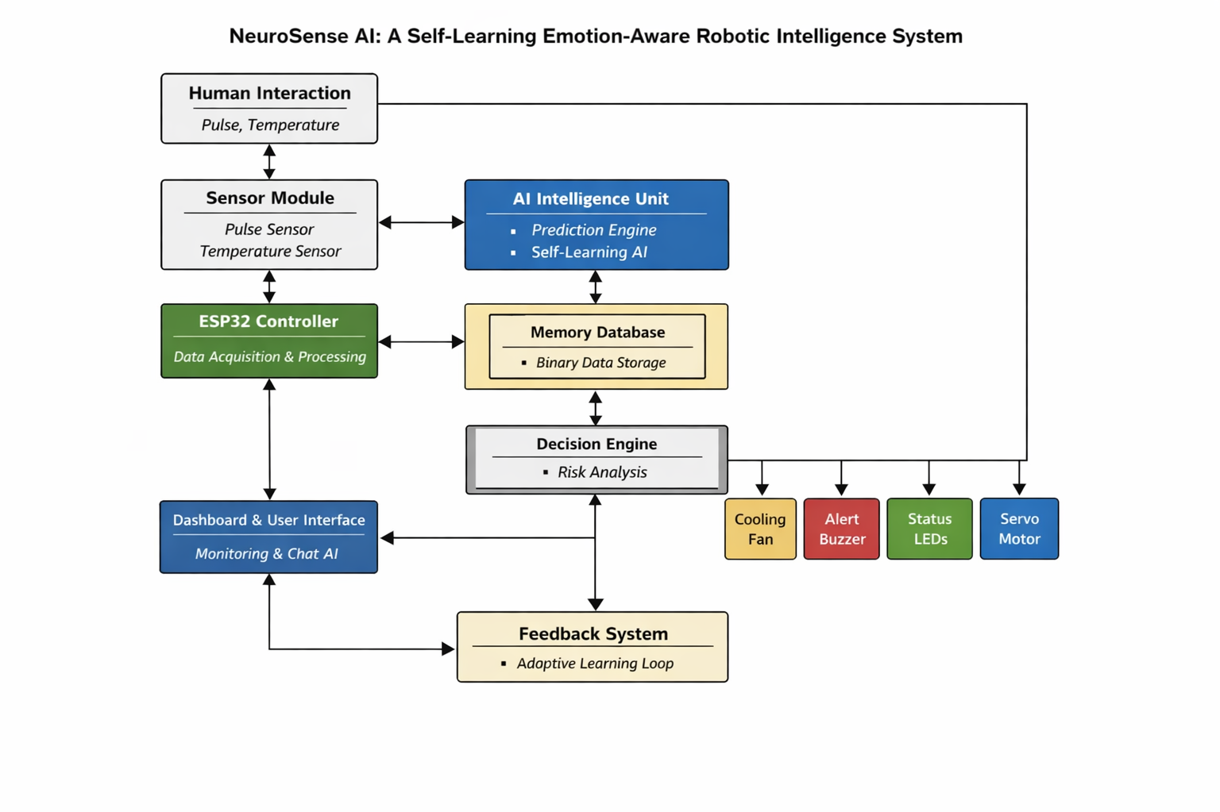
4.7.1 Block Diagram Explanation
The complete working structure of the NeuroSense AI system. It shows how different modules interact to create a continuous sensing, learning, and response cycle.
Below is the explanation of each block:
1. Human Interaction
- Represents the human user connected to the system.
- Body signals such as pulse rate and temperature are generated naturally.
- These signals form the primary input for the system.
- The system focuses on understanding human condition rather than only performing tasks.

2. Sensor Module
- Includes pulse sensor and temperature sensor.
- Continuously monitors physiological signals.
- Converts physical signals into digital data.
- Sends real-time data to the ESP32 controller.

3. ESP32 Controller (Data Acquisition & Processing)
- Acts as the central hardware controller.
- Collects sensor data.
- Performs basic filtering and processing.
- Transfers processed data to the AI Intelligence Unit.
- Ensures fast response without cloud dependency.

4. AI Intelligence Unit
- Core brain of the system.
- Contains:
  - Prediction Engine
  - Self-Learning AI
- Analyzes patterns in pulse and temperature data.
- Predicts stress levels and potential risks.
- Continuously improves performance using stored experiences.

5. Memory Database (Binary Storage)
- Stores historical sensor data.
- Maintains AI learning memory.
- Uses compact binary format for efficiency.
- Helps the system learn from past conditions.
- Supports personalized decision-making.

6. Decision Engine (Risk Analysis)
- Receives analyzed data from AI module.
- Performs risk assessment.
- Classifies stress level (Normal, Medium, High).
- Determines appropriate response action.
- Acts as the control logic for hardware activation.

7. Response Modules
Based on AI decisions, the following components are activated:
• Cooling Fan
- Reduces heat or discomfort.
- Activated during high temperature or stress.
• Alert Buzzer
- Provides audible warning.
- Used during critical stress conditions.
• Status LEDs
- Visual indication of system status.
- Green → Normal
- Yellow → Medium
- Red → High
• Servo Motor (Robotic Arm)
- Controls robotic movement.
- Adjusts behavior based on human condition.

8. Dashboard & User Interface
- Displays real-time data.
- Shows AI predictions.
- Provides system status updates.
- Includes chat-style AI output.
- Allows user interaction and monitoring.

9. Feedback System (Adaptive Learning Loop)
- Collects user feedback.
- Evaluates whether system response was correct.
- Updates AI model for improved performance.
- Creates continuous improvement loop.
- Makes system adaptive and intelligent over time.

Overall System Flow
- Human generates body signals
- Sensors capture data
- ESP32 processes input
- AI analyzes and predicts stress
- Memory stores experience
- Decision engine selects action
- Hardware responds
- Dashboard displays status
- Feedback improves AI
This cycle repeats continuously.

Final Summary for Report
The block diagram demonstrates a layered architecture where sensing, intelligence, memory, decision-making, and action work together in a unified loop. This structure transforms the system from a simple monitoring device into an emotion-aware, predictive, and adaptive robotic intelligence platform.

CHAPTER - 5

RESULT AND DISCUSSION

5.1 SAMPLE CODE (DATABASE CODE)
import sqlite3
from datetime import datetime
DB_NAME = "robo_ai.db"
def init_db():
conn = sqlite3.connect(DB_NAME)
c = conn.cursor()
c.execute("""
CREATE TABLE IF NOT EXISTS sensor_data (
id INTEGER PRIMARY KEY AUTOINCREMENT,
temperature REAL,
pulse INTEGER,
stress TEXT,
servo1 INTEGER,
servo2 INTEGER,
servo3 INTEGER,
servo4 INTEGER,
timestamp TEXT
)
""")
conn.commit()
conn.close()
def insert_data(data):
conn = sqlite3.connect(DB_NAME)
c = conn.cursor()
c.execute("""
INSERT INTO sensor_data
(temperature, pulse, stress, servo1, servo2, servo3, servo4, timestamp)
VALUES (?, ?, ?, ?, ?, ?, ?, ?)
""", (
data["temperature"],
data["pulse"],
data["stress"],
data["servo1"],
data["servo2"],
data["servo3"],
data["servo4"],
str(datetime.now())
))
conn.commit()
conn.close()
def fetch_latest(limit=50):
conn = sqlite3.connect(DB_NAME)
c = conn.cursor()
c.execute("""
SELECT temperature, pulse, stress, servo1, servo2, servo3, servo4
FROM sensor_data
ORDER BY id DESC
LIMIT ?
""", (limit,))
rows = c.fetchall()
conn.close()
return rows

5.2 RESULT
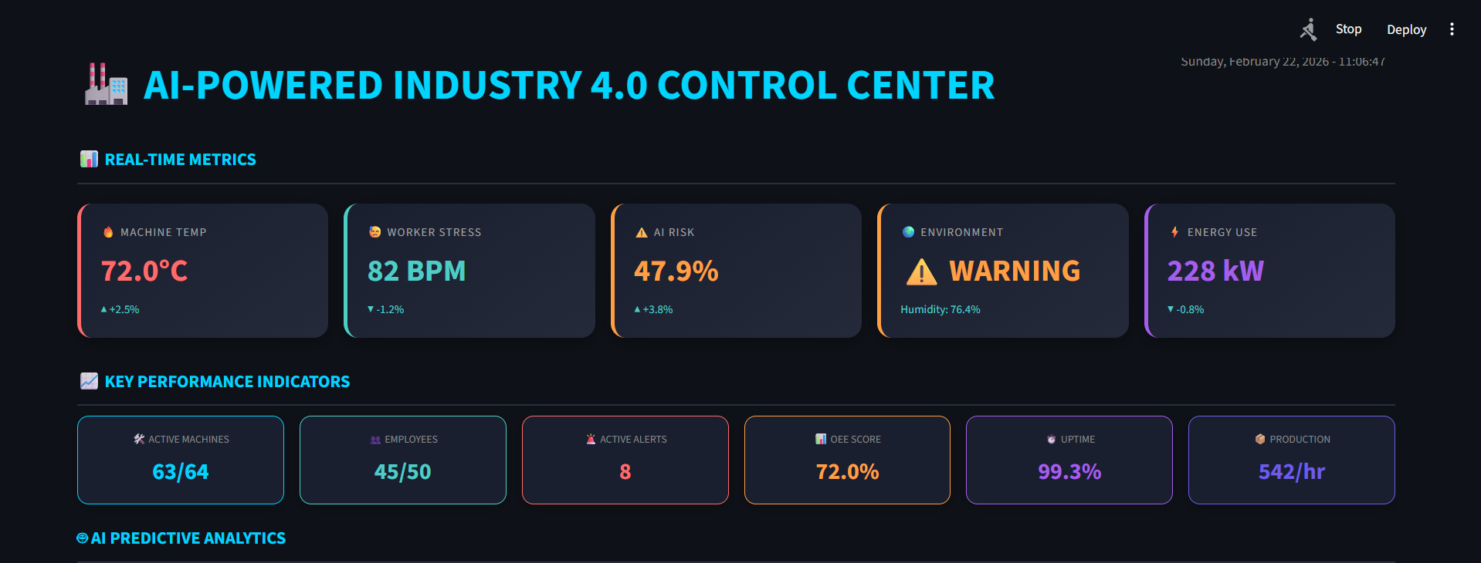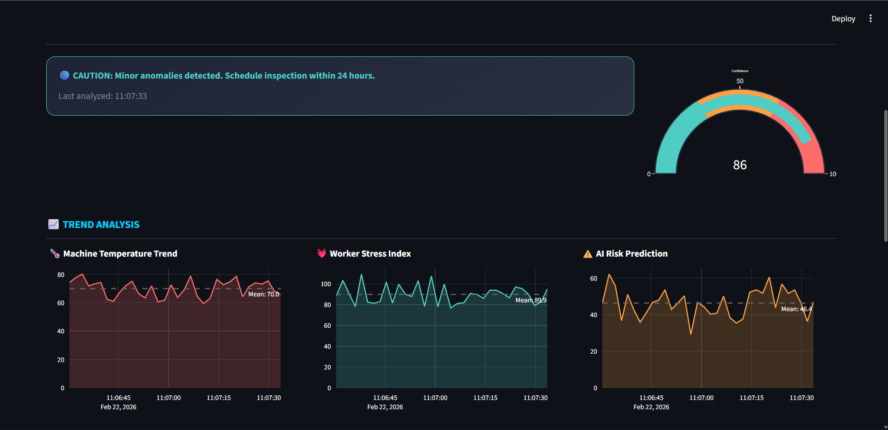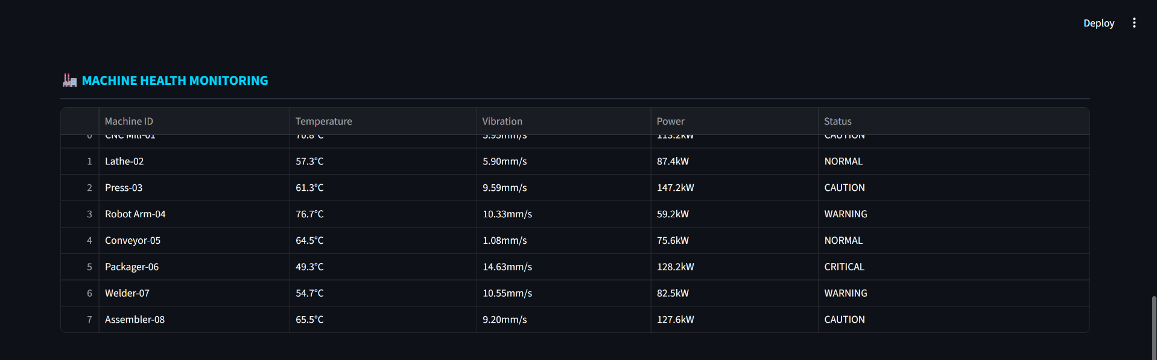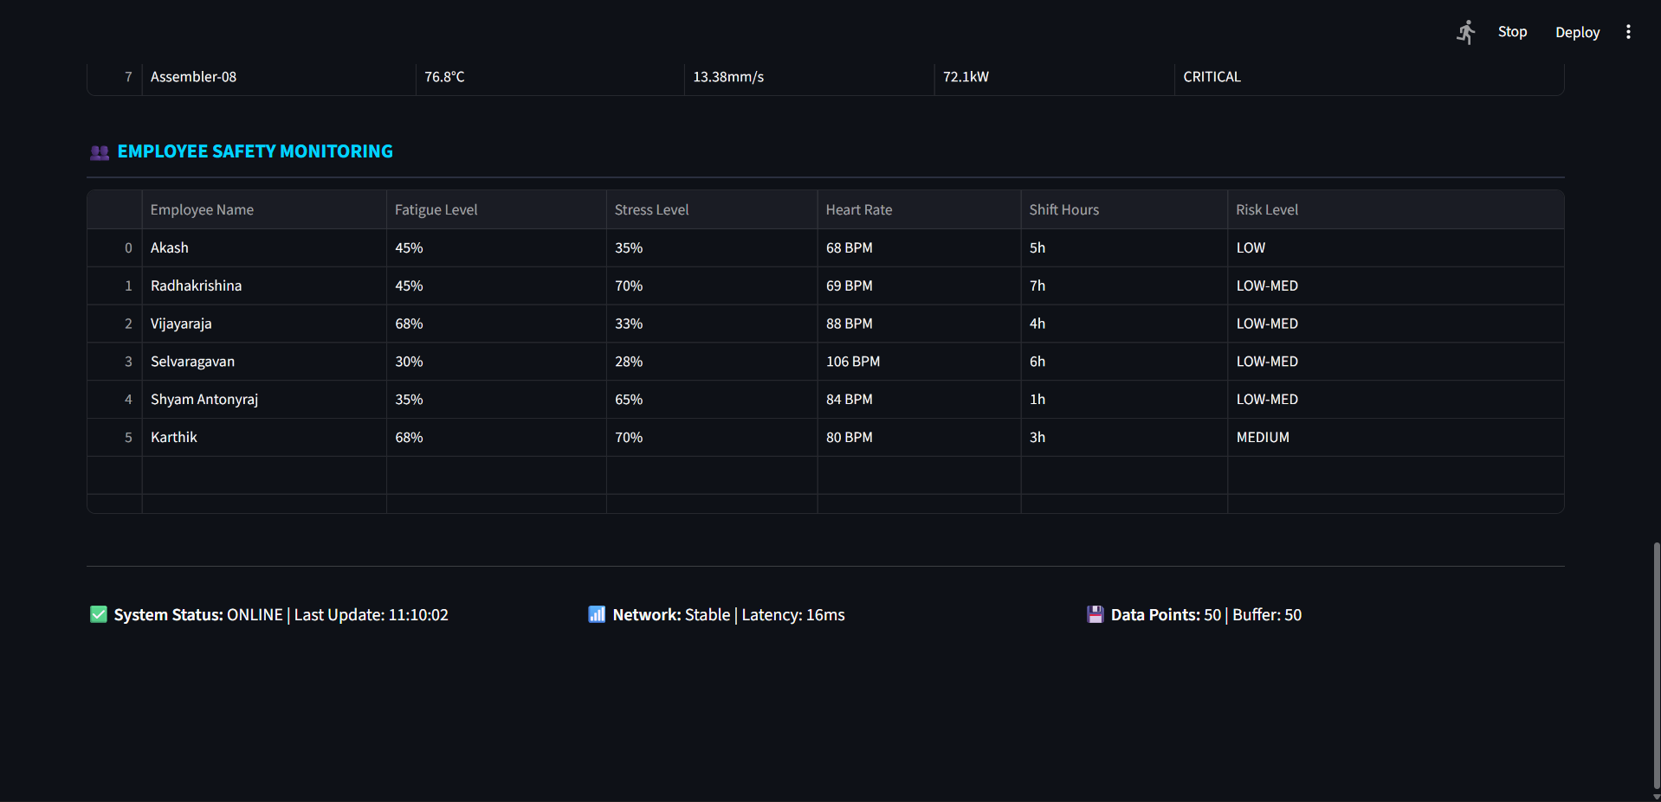

CHAPTER – 6
CONCLUSION

NeuroSense AI: A Self-Learning Emotion-Aware Robotic Intelligence System
This project demonstrates a new direction in the way humans and machines can work together. Traditional machines are designed to follow instructions and perform tasks efficiently, but they often lack awareness of human condition. NeuroSense AI explores a different approach by creating a system that focuses on understanding and supporting human well-being rather than only completing mechanical tasks.
The main goal of this project was to build an intelligent robotic system that can sense basic human body signals and respond in a meaningful way. By combining simple sensors, artificial intelligence, and adaptive robotic behavior, the system is able to monitor stress levels and take preventive actions. Instead of reacting after problems occur, the system aims to identify early warning signs and provide supportive responses such as alerts or environmental adjustments. One of the most important achievements of this project is the integration of self-learning intelligence. The system is designed to improve over time by remembering past experiences and learning from feedback. This allows the AI to become more accurate and personalized with continued use. The ability to learn and adapt makes the system more flexible and future-ready compared to static automation systems.
Another key outcome is the development of a low-cost and scalable prototype. The project proves that advanced ideas like emotion-aware AI and predictive robotics can be implemented using simple and accessible components. This makes the concept practical for further development and real-world applications. NeuroSense AI also highlights the potential of human-centered design in technology. By focusing on safety, empathy, and prevention, the system opens new possibilities for applications in industries, hospitals, elderly care, and assistive robotics. It shows how machines can evolve from tools into supportive companions that enhance human safety and comfort.

In conclusion, NeuroSense AI represents an important step toward the future of intelligent and human-aware systems. While the current version is a prototype, it provides a strong foundation for further innovation. With continued development, such systems can transform how we interact with technology, making machines not only smarter but also more understanding and helpful in everyday life

REFERENCE

1. Emotion in Reinforcement Learning Agents and Robots
Moerland, T. M., Broekens, J., & Jonker, C. M.
- A well-known survey explaining how emotions can be integrated into reinforcement learning agents and robots. (ACM Digital Library)
- Shows emotions improve decision-making and human interaction in AI systems. (arXiv)

2. Self Context-Aware Emotion Perception in Human-Robot Interaction
Lin, Z., Cruz, F., & Sandoval, E. (2024)
- Introduces a context-aware emotion model improving long-term emotion detection accuracy in robots. (arXiv)

3. Speech Emotion Recognition for Intelligent Robots
Kang, X. (2025)
- Proposes advanced AI models for detecting emotions from human speech in robots. (ScienceDirect)
- Addresses challenges like emotional ambiguity in AI understanding. (ScienceDirect)

4. Emotion Recognition from Robot Body Movements
Gao, W. (2024)
- Uses neural networks to map robot movements with emotional states. (MDPI)
- Shows optimization improves emotion recognition accuracy. (MDPI)

5. ProxEmo: Emotion Learning for Social Robot Navigation
Narayanan et al. (2020)
- Predicts human emotions from walking patterns for socially aware robots. (arXiv)
- Used in real robots for emotion-guided navigation. (arXiv)

6. Emotion-Aware Robotics Using Reinforcement Learning
IJNRD Research Paper
- Shows emotion-aware robots are useful in healthcare and assistive systems. (IJNRD)
- Discusses cognitive feedback and adaptive learning in robots. (IJNRD)

7. Emotion Recognition in Autism Therapy Using Social Robots
Bhattacharjee et al. (2025)
- Deep learning model for detecting subtle emotions in children using robots. (arXiv)
- Strong application in healthcare robotics. (arXiv)

8. Socially Intelligent Emotional Robots Research (Example Systems)
- Early projects like Feelix Growing explored robots that learn emotional responses from humans. (Wikipedia)
- Emotional robots like AISoy1 adapt behavior based on emotional stimuli. (Wikipedia)

9. Emotionally Intelligent Robots in Human Interaction
- Social robots like Furhat demonstrate real-time emotion interaction and expression. (Wikipedia)
- AI emotion systems like EmoSpark analyze human emotions and respond dynamically. (Wikipedia)

